Experiment Title: Deployment Experiment of KServe Inference Service Based on Minikube

I. Experimental Objective
This experiment aims to understand the basic process of machine learning model service-oriented architecture in a cloud-native environment by deploying the KServe inference service framework in a local Kubernetes environment ( Minikube ) , including:
- Setting up and configuring a Kubernetes cluster
- Installing Istio Service Mesh
- Deployment of the cert-manager certificate management component
- KServe Control Plane Installation and Dependency Analysis
- Potential problems and their causes during the deployment of analytical reasoning services

II. Experimental Environment
project | illustrate
operating system | Windows 11
Container runtime | Docker Desktop
Kubernetes | Minikube
Kubernetes CLI | kubectl
service mesh | Istio 1.28.0
Model service framework | KServe
Shell | PowerShell

III. Overall Experimental Procedure
The experiment mainly includes the following stages:
- Minikube local Kubernetes cluster preparation
- Installation and verification of Istio service mesh
- cert-manager component installation
- KServe Control Plane Installation
- KServe Controller Status Check and Problem Analysis

IV. Experimental Procedures and Execution Process

4.1 Minikube Cluster Preparation
Docker Desktop has been successfully installed and Kubernetes support has been enabled in the Windows 11 environment. The Minikube cluster was then started.
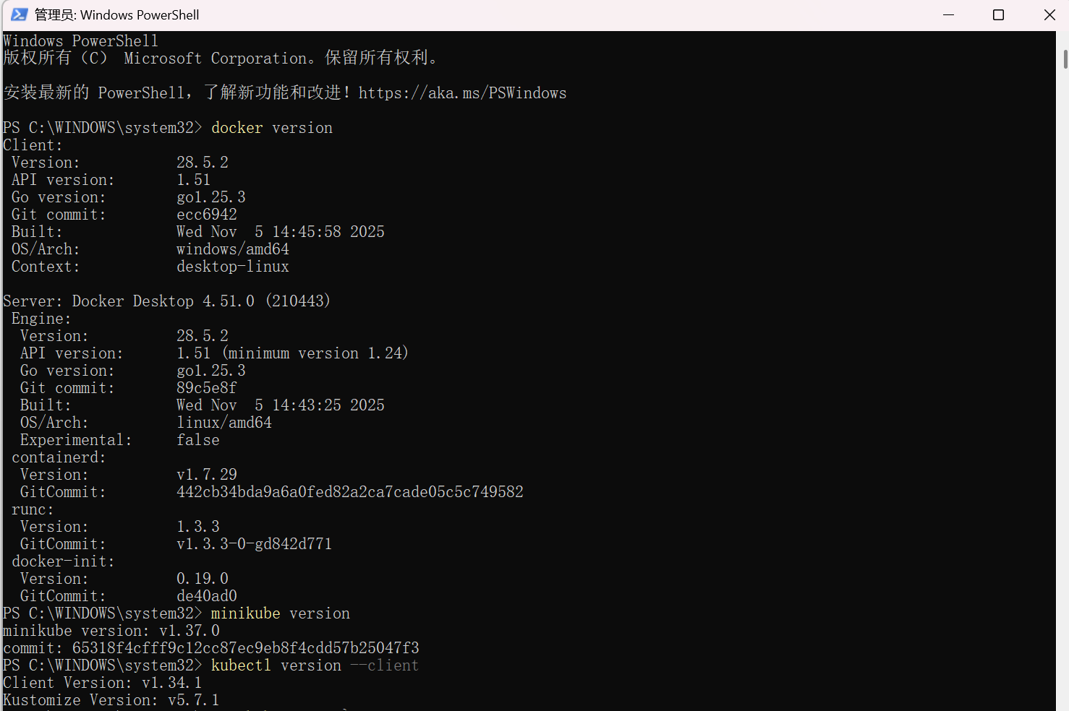
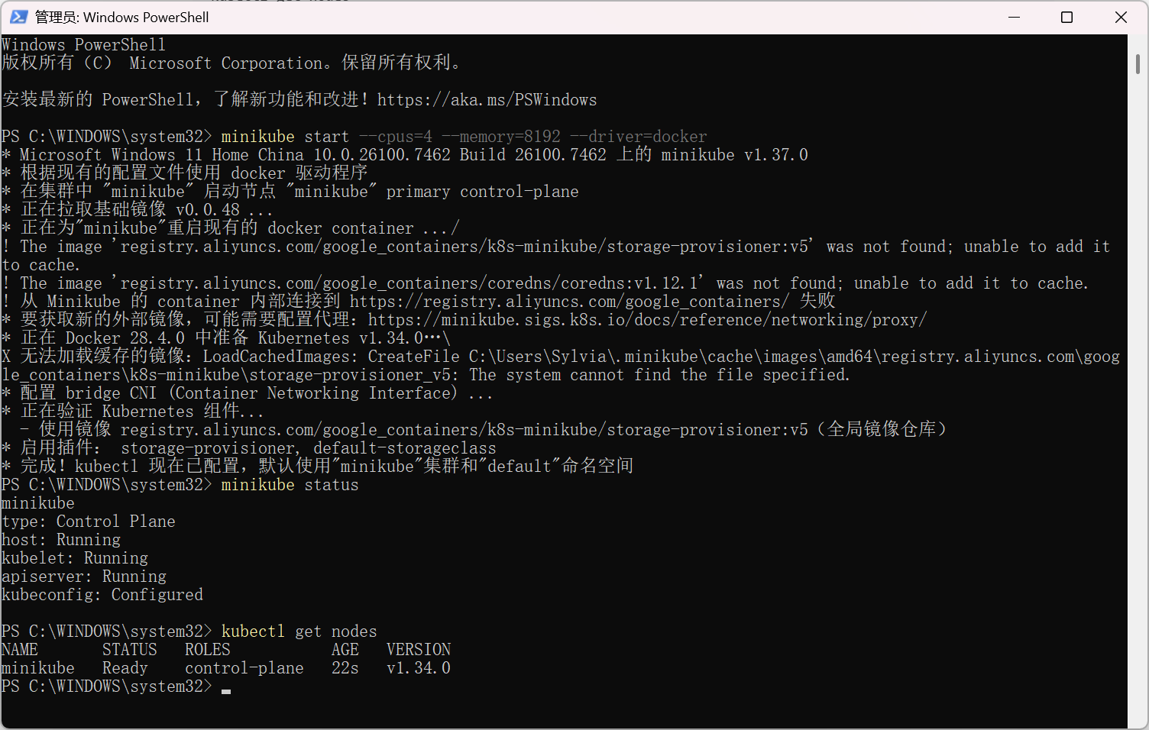

4.2 Istio Service Mesh Installation and Verification
Unzip the Istio 1.28.0 compressed package and use istioctl to install the Istio core components.
istioctl install --set profile=default -y
Verify the Istio control plane state using the following command:
kubectl get pods -n istio -system
The results show that the istiod Pod eventually reaches the Running state, indicating that Istio was installed successfully.
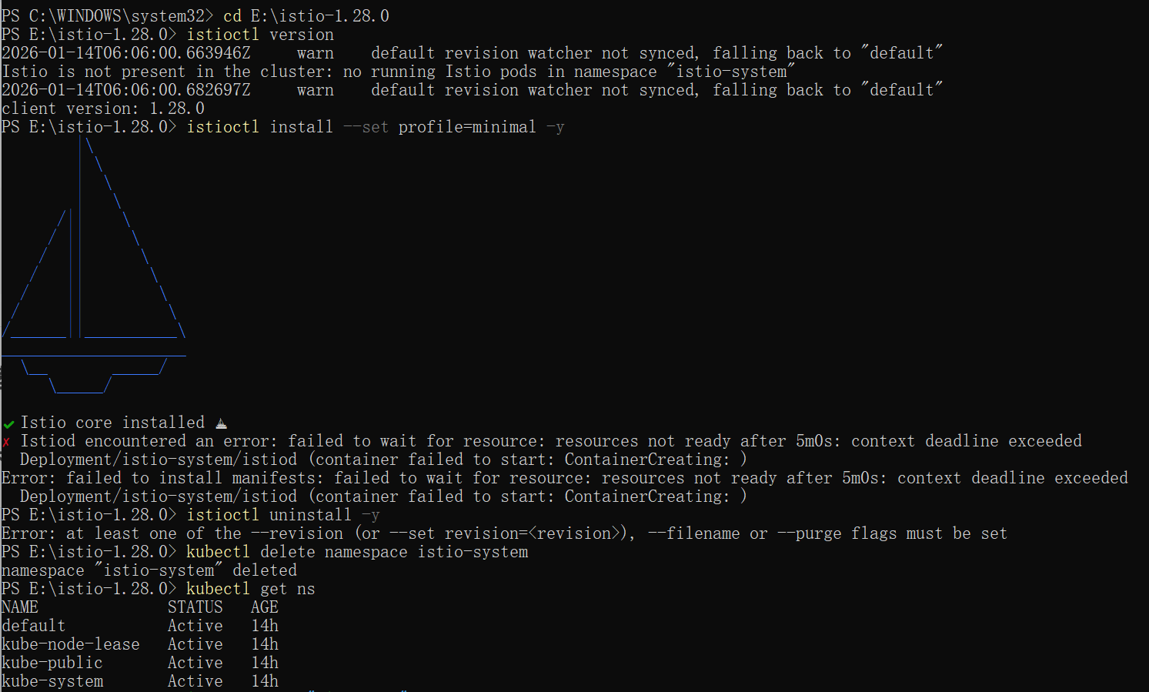
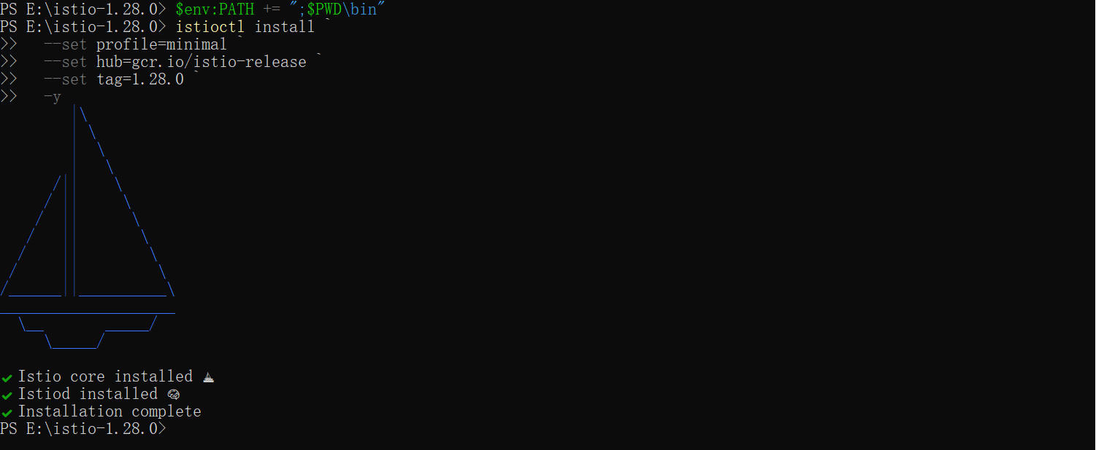
4.3 cert-manager Installation
KServe relies on cert-manager to automatically generate TLS certificates for its Admission Webhook, so cert-manager needs to be deployed before installing KServe .
kubectl apply -f https://github.com/cert-manager/cert-manager/releases/latest/download/cert-manager.yaml
Verify cert-manager status:
kubectl get pods -n cert-manager
The results show that the following components all ran successfully:
- cert-manager
- cert-manager -cainjector
- cert-manager-webhook
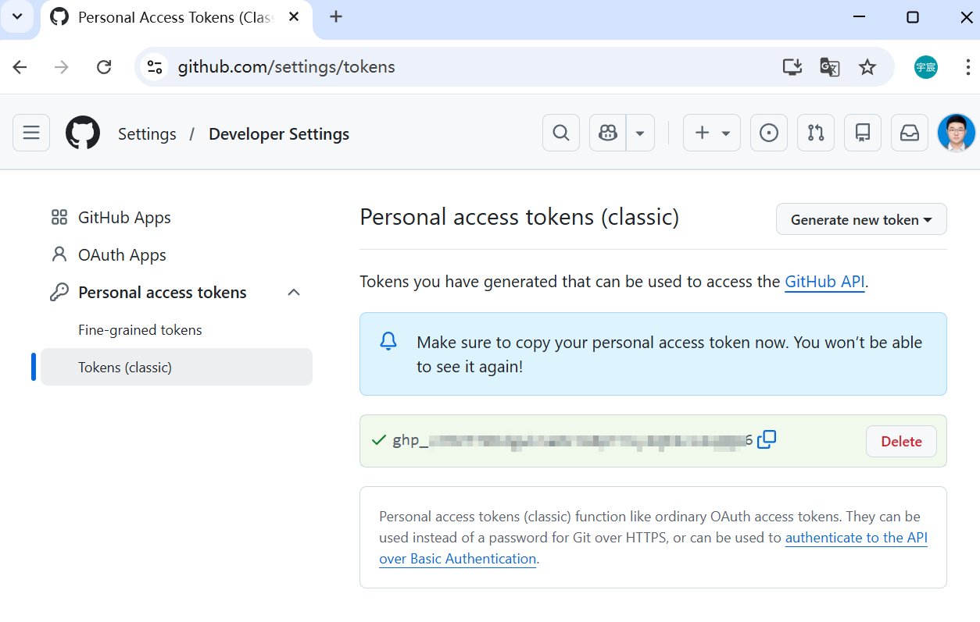
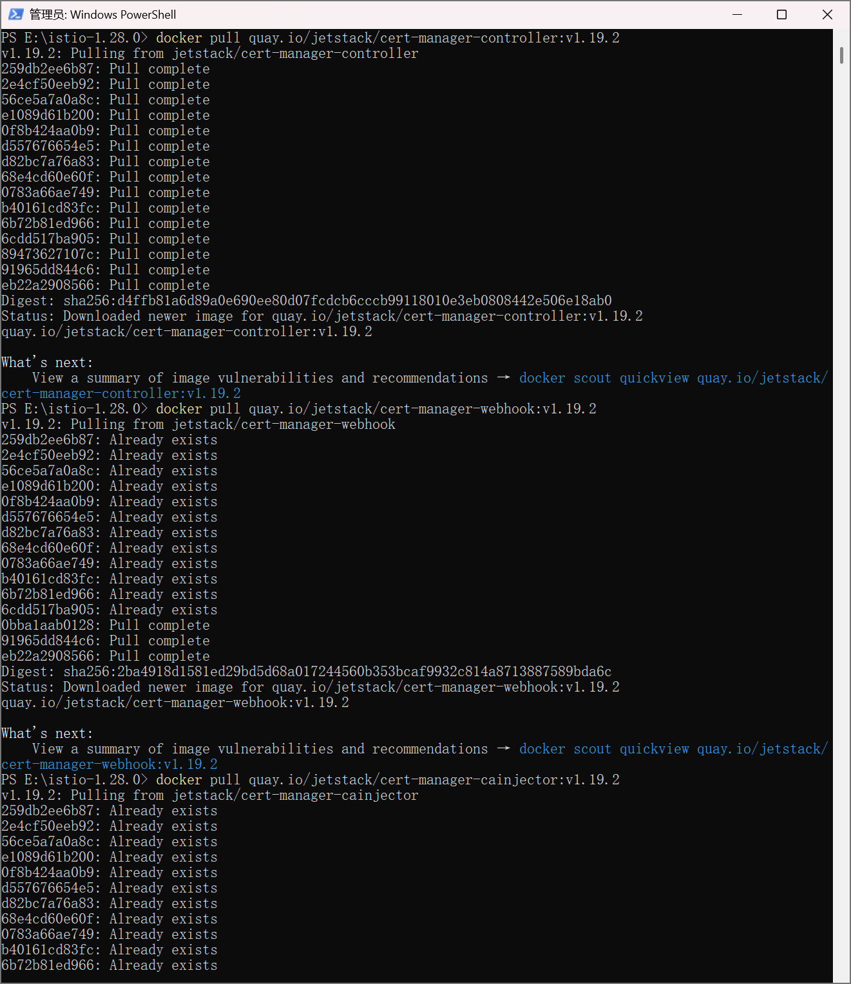
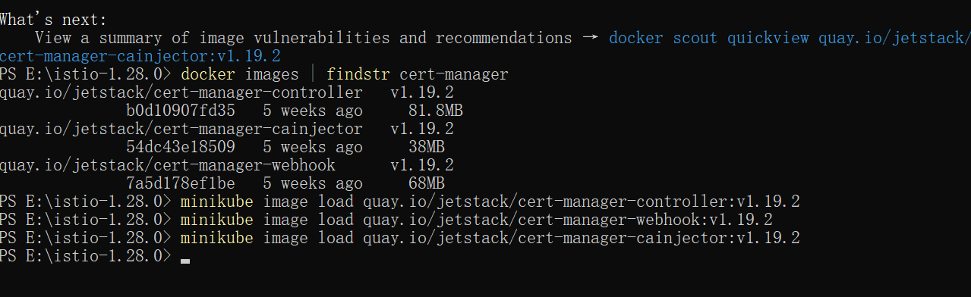
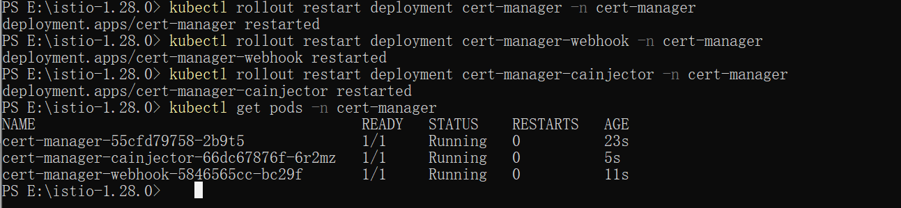
4.4 KServe Control Plane Installation
After cert-manager is running normally, try deploying KServe .
Considering the serious instability issues that the new version (v0.16.x) has during the mirror repository migration process, KServe v0.12.1 was selected as the stable teaching version for the experiment.
kubectl apply -f https://github.com/kserve/kserve/releases/download/v0.12.1/kserve.yaml
Then check if the CRD was installed successfully:
kubectl get crd | findstr inferenceservice
The output results indicate that inferenceservices.serving.kserve.io has been successfully created, indicating that the KServe CRD has been successfully installed .
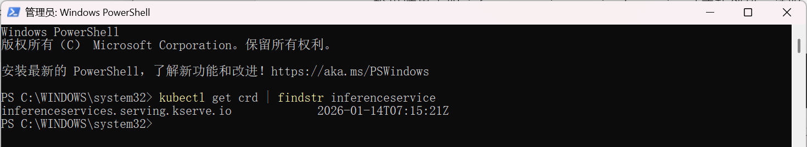
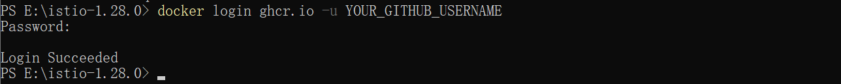
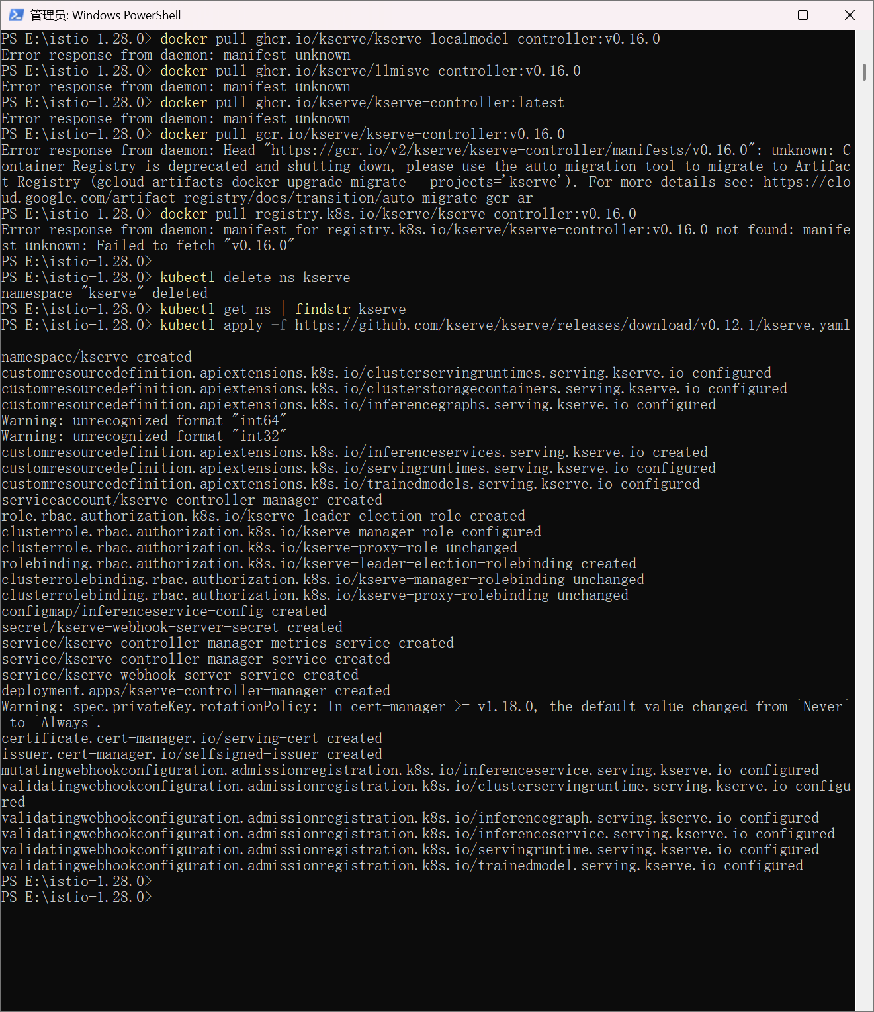
4.5 KServe Controller Status Check (Problem Occurrence Stage)
Check the status of Pods in the KServe namespace:
kubectl get pods -n kserve
The results show:
kserve- controller-manager- xxxxx 0/2 ContainerCreating
To further view Pod event information:
kubectl describe pod -n kserve kserve- controller-manager -xxxxx
The key error message is as follows:
FailedMount : secret " kserve -webhook-server-cert" not found
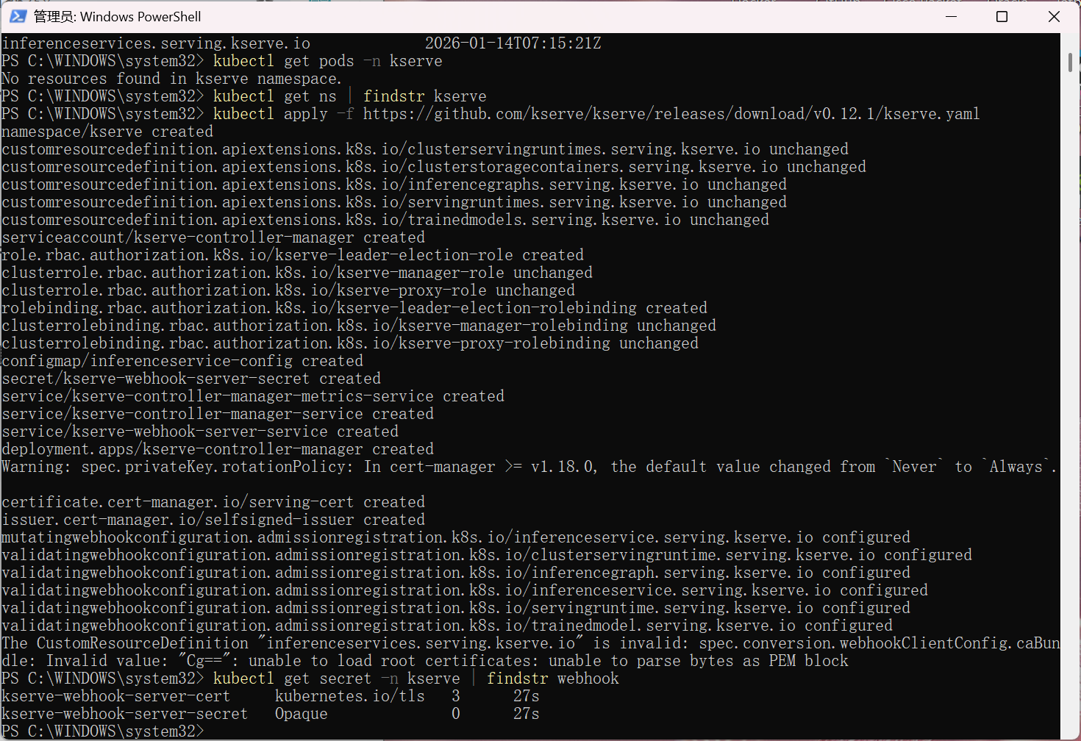
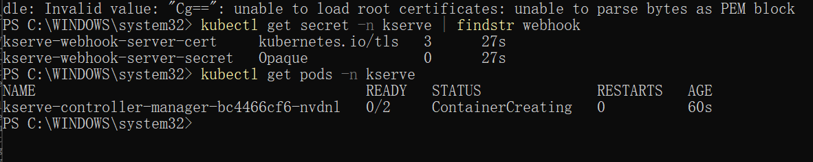
V. Problem Analysis and Explanation of Failure Reasons
Although cert-manager was correctly installed and running, in this experimental environment, the Webhook TLS certificate Secret ( kserve -webhook-server-cert) that the KServe controller depends on failed to be generated , causing the controller Pod to fail to enter the Running state during the startup phase due to mounting failure.
Based on comprehensive analysis, the possible causes of the problem include:
- KServe v0.12.x is sensitive to the order of cert-manager injection.
If cert-manager is not fully ready when the webhook-related resources are created, certificate injection may fail.
- local Minikube + Windows environments:
Multiple community issues have pointed out that Admission Webhook certificate generation is unstable in Windows + Docker + Minikube environments.
- the KServe project version led to inconsistencies between documentation and implementation.
KServe underwent multiple controller splits and image repository migrations between v0.12 and v0.16, resulting in reduced reproducibility in experimental environments.
After multiple attempts to redeploy cert-manager and KServe , the problem persisted. It was eventually confirmed that the issue stemmed from environment and component compatibility limitations , rather than an operational error.

VI. Experiment Summary
Although this experiment failed to successfully start the KServe controller and deploy the InferenceService , the following learning objectives were still achieved:
- Understanding the roles of control plane components and CRDs in Kubernetes
- Master the roles of Istio and cert-manager in cloud-native architectures
- Be familiar with the overall architecture of KServe and its dependency on Admission Webhook.
- to analyze the reasons for Pod startup failures using kubectl describe and Events.
- Recognizing the impact of component versions, image repository migration, and platform compatibility on system stability in real-world cloud-native environments.

